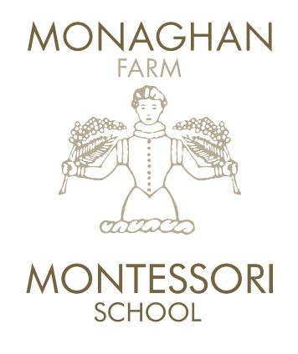
INDEMNITY FOR
FARM ACTIVITIES

- The School offers certain activities for the Children to participate in on the Monaghan Farm (“the Farm”) which include but are not limited to, going for walks on the Farm and interacting with farm animals on the Farm (“the Farm Activities”).

- While Monaghan Montessori its proprietors, its employees and duly authorised representatives acting in such capacity (“the School”) shall at all times use its best endeavours to ensure the safety and well-being of the Child at the School and while participating in the Farm Activities, the School shall, to the extent permitted by law, not be liable under any circumstances whatsoever, including but not limited to any loss, injury, illness, death and/or damages, to the person and/or property of the Child, and/or to the person and/or property of his/her Parent/Guardian whilst being in the care of, and/or on the premises of, the School and/or whilst being in the care of the School on the Farm, for any purposes whatsoever, unless such loss, injury, illness, death and/or damages arise as a result of gross negligence on the part of the School.

____________
*Initial here

- I, _________________________ (full name and surname) (“the Parent/Guardian”) the Parent/Guardian of ____________________________ (full name and surname) (“the Child”) –

  - give consent for the Child to take part in any of the Farm Activities of the School, whether conducted on the premises or on the Farm;

  - fully understand that the Farm Activities may contain risk of an unusual nature and accept that the Farm Activities shall be undertaken at the Child's own risk and undertake on behalf of myself, my spouse, my executors and the Child to indemnify, hold harmless and absolve the School against and from any or all claims whatsoever which may arise in connection with any loss, injury, illness, death and/or damage to the person and/or property of the Child in the course of the Farm Activities; and
____________
*Initial here

  - in the event of the Child being injured while participating in the Farm Activities, I give my permission to the School to attend to such injury in loco parentis and to consent to any medical treatment should such consent be required for medical reasons on an urgent basis and should it not be possible for me and/or the Child’s other Parent/Guardian to be contacted timeously, and/or in the case where I or the Child’s other Parent/Guardian cannot be reached.

Signed on this the ___ day of ____________ 20__.

_________________________
Signature of Parent /Guardian

